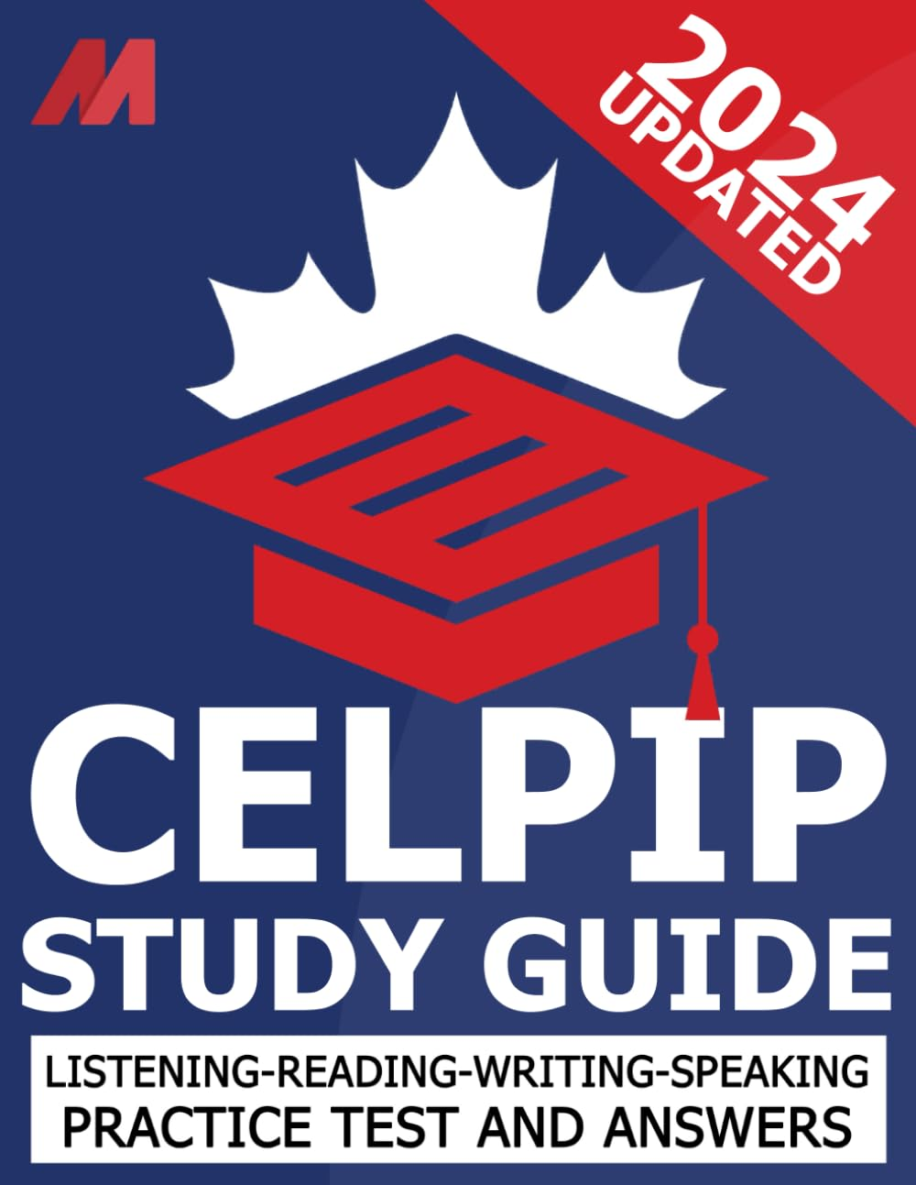 ₦53,000
CELPIP General Practice Test - CELPIP Study Guide and Practice Test and Answers (CELPIP Prep)

